**CP Club 365 Days Challenge**

**Programming language – C++**

**Problem Statement**

<https://www.codechef.com/problems/START01>

Git :- <https://github.com/Vedantbharad2603/CP_club_365_Days>

**Your Code**:

// 0x129Day of 0x365Days challenge

// VEDANT BHARAD

// 23-2-2023

#include <iostream>

using namespace std;

int main() {

    // your code goes here

    int n;

    cin>>n;

    cout << n << endl;

    return 0;

}

**Output (Screen Shot)**:

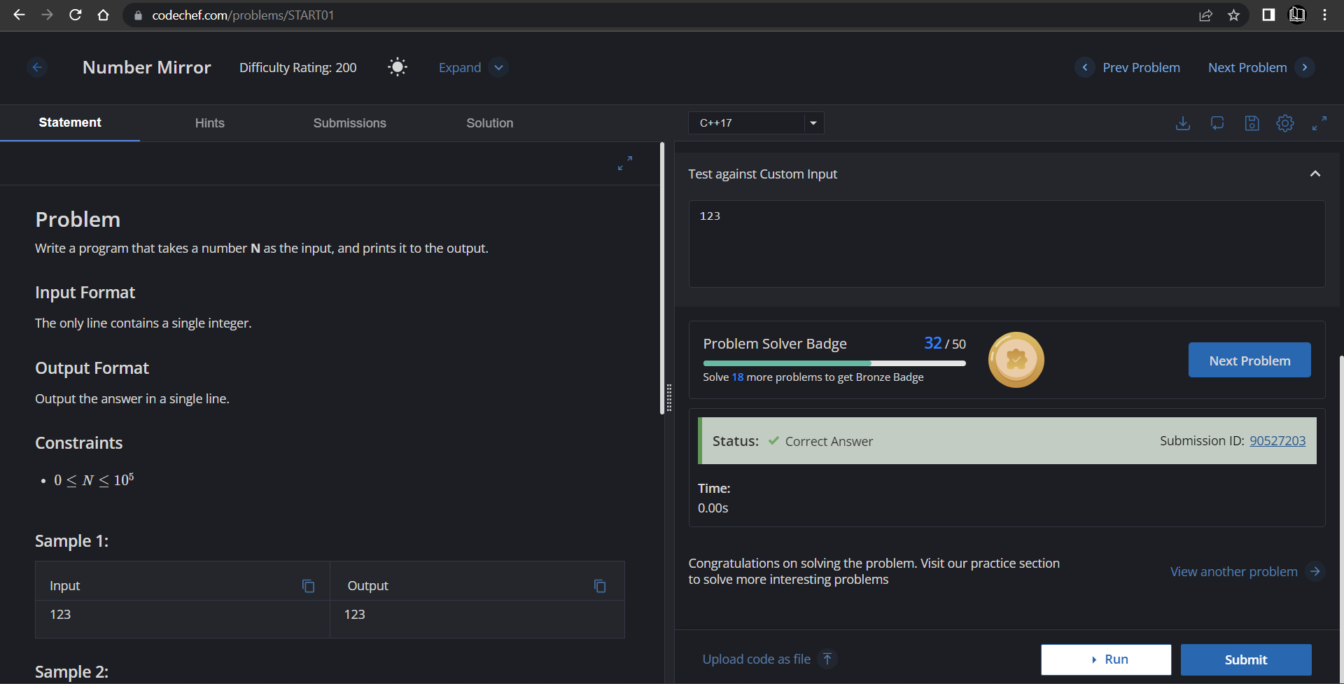

**Understanding about problem:**

* In this task I need to take one number and print that number.

Note: If you can't understand the problem, feel free to contact us and we'll help you. Please don't copy and paste from anywhere.

ALL THE BEST

Team CP Club